- Create user with name Techie and provide sudo access to user.
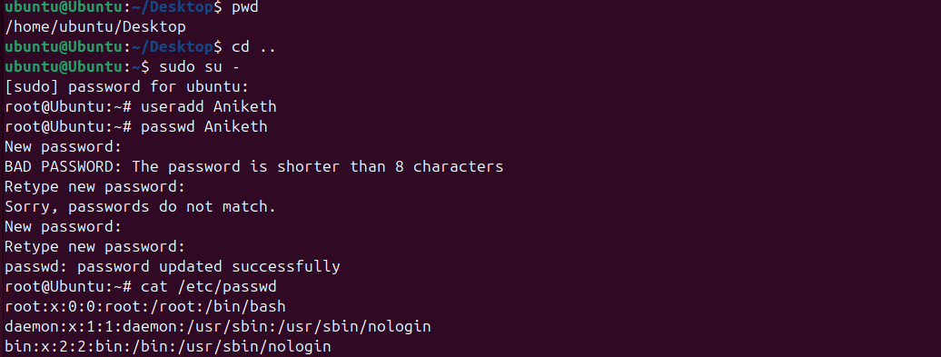
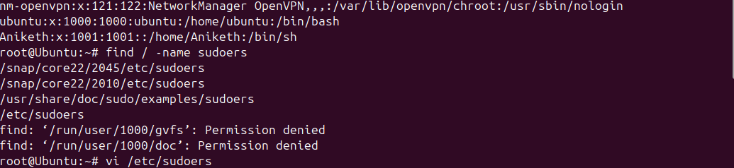

User : Aniketh passwd:devops0509
In vi /etc/sudoers we need to add user in allow sudoers command.

- Navigate to the home directory.

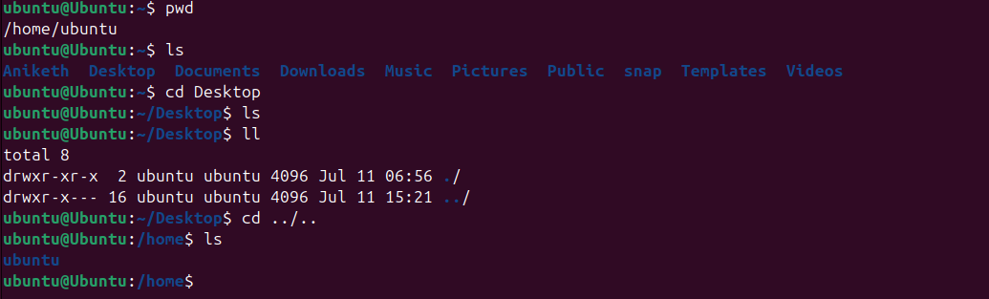

To navigate home directory we need to check present working directory by comand “pwd”
Accordingly we can go back by command “cd ..” to home.

- Create a new directory.

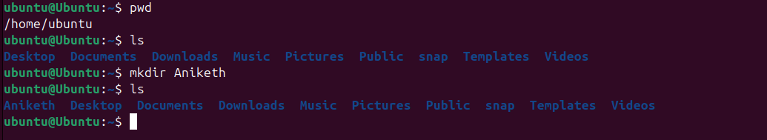

To create a directory the command used is “mkdir” directory name.

4) List the contents of a directory.

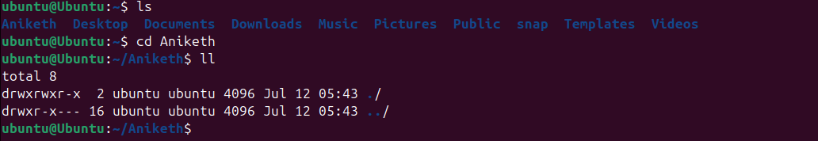

To get list of content of directory the command used is “ll”.

5)Change the current directory.

To change current directory the command used is “cd directory name”.

- Create a new empty file.

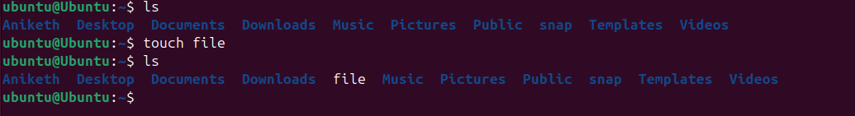

To create a new empty file the command used is “touch filename”.

- View the contents of a file.

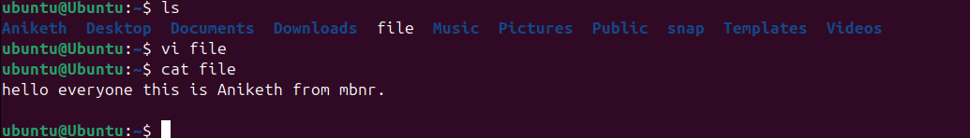

To view the contents of file the comand used is “cat filename”.

- Copy a file to another location.

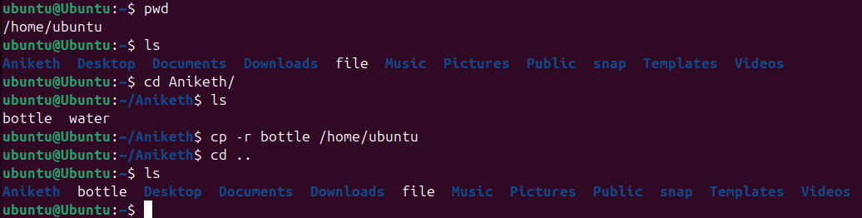

To copy a file the command used is “cp -r filename path location”.

- Move a file to another location.

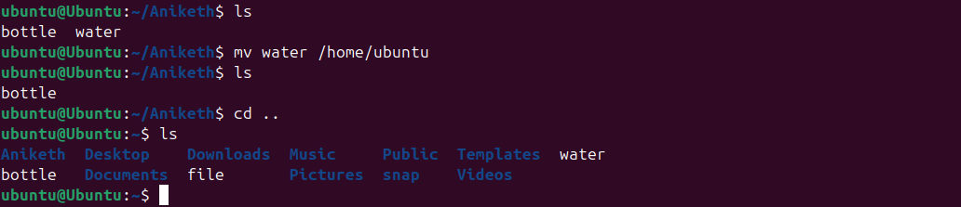

To move a file to another location the command used is : “mv filename pathlocation”.

10) Rename a file.



To rename a file the command used is : “mv filename new filename ”

11) Delete a file.

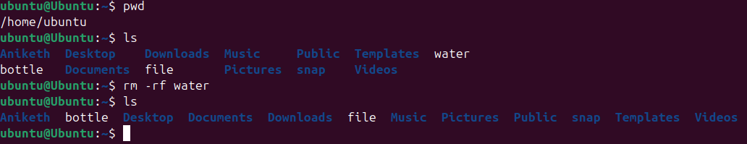

To delete a file the command used is : “rm -rf filename”.

- Grant or revoke permissions on a file or directory.

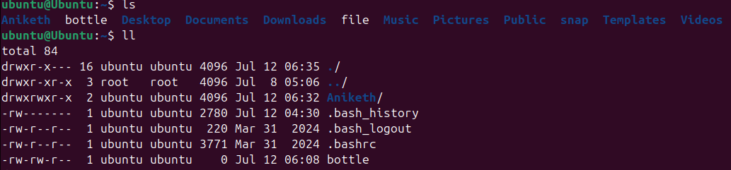
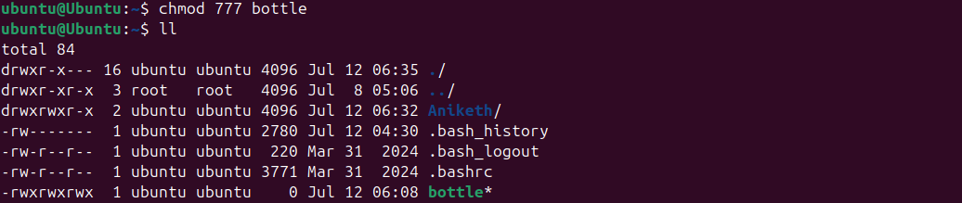

To grant or revoke permissions of file or directory the command used is
: “chmod 777 file or directory name”
Where 777 is determined as combination of read write execute .

13) View the current date and time.

To view the current date and time the command used is “time”.

14) check the system uptime.

To check the system uptime the command used is “uptime”.

15) View the running processes.

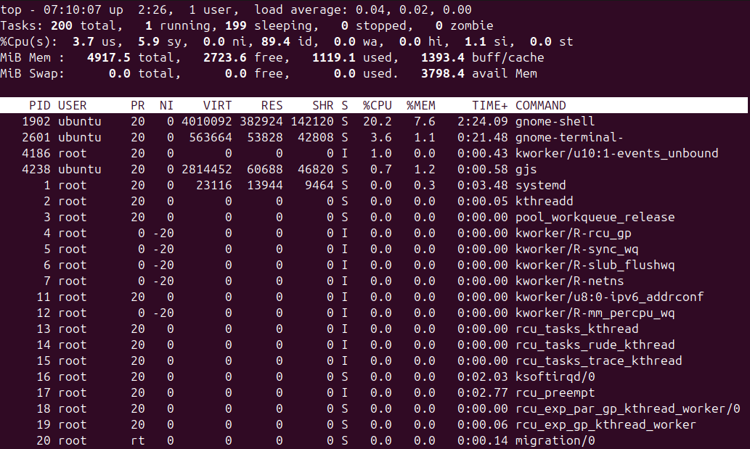

To view the running processes the command used is : “top”. and also “ps -ef”.

- Kill a running process

To kill a running process the command used is : “kill -9 PID”
Where PID= process id .

17) Install a package using the package manager (e.g., apt or yum).

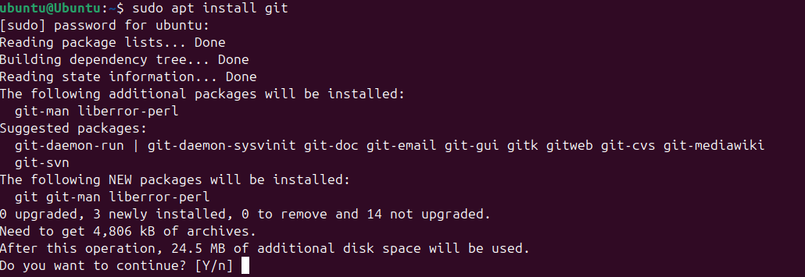

To install a package , the command used is : “sudo apt install packagename”.

18)Update the system packages.

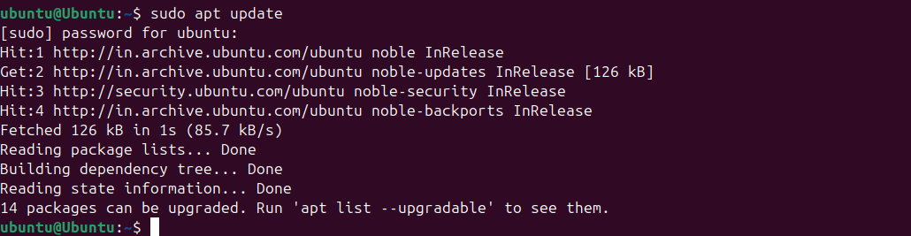
To update the system package, the command used is : “sudo apt update”.

19)Create a symbolic link.

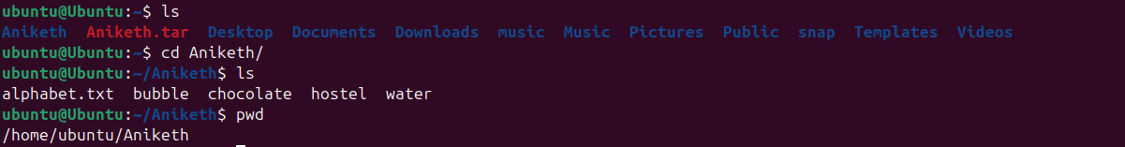

To create a symbolic link for a file the command is
ln -s /home/aniketh/Documents/data.txt /home/aniketh/Desktop/link_to_data.txt

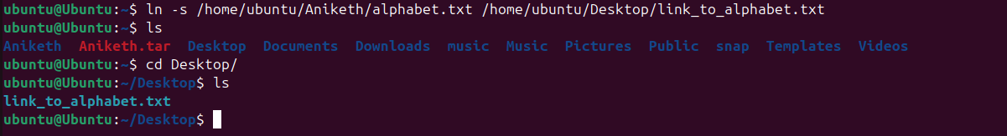

In same way symbolic link for directory the command is :
ln -s /home/aniketh/Documents/ProjectFiles /home/aniketh/Desktop/ProjectLink

20)Search for files using the find command.

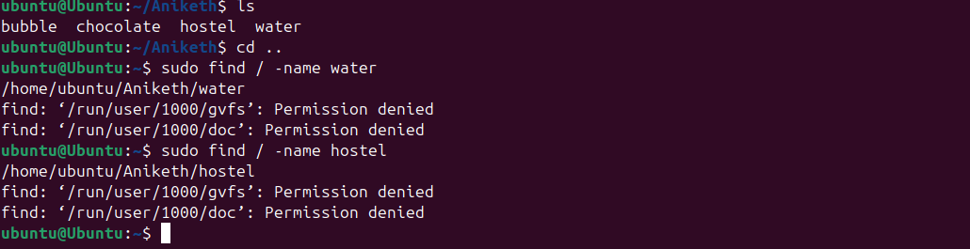

To search files the command used is : “find / -name filename”

21)Compress and decompress files using tar.

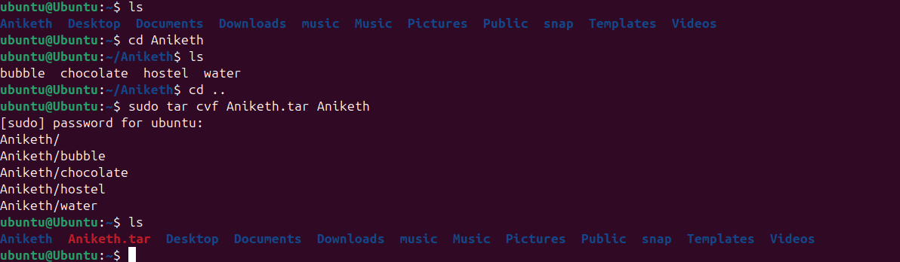

To compress the file using tar the command is :
[ sudo tar cvf “filename.tar” “filename” ]

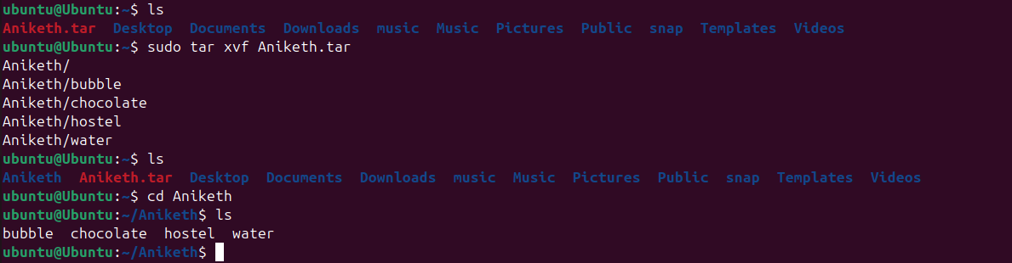

To decompress or extract the file using tar command is :
[ sudo tar xvf “filename.tar” ]

22)Monitor system resources with top or htop.

23)Create and manage user groups.

To create user groups the command is :
sudo groupadd groupname
To get the list of groups , command is :
getent groups

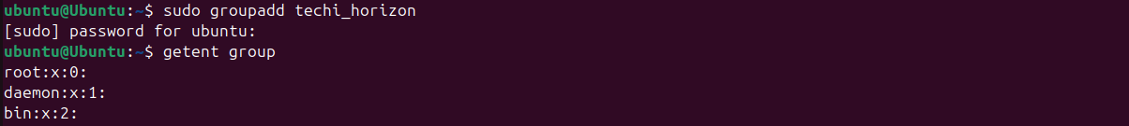

To add user to group the command is :
sudo usermod -aG groupname username

To delete the group the command used is
sudo groupdel groupname .

25)Monitor log files using tail or grep.

First to check log files in system the command is

ls /var/log
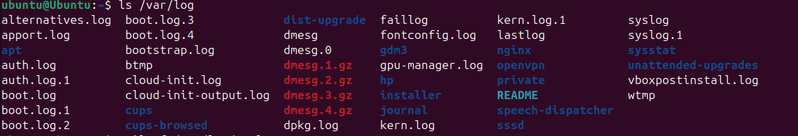

To moniter log files using tail command is
sudo tail -f /var/log/ logfile name
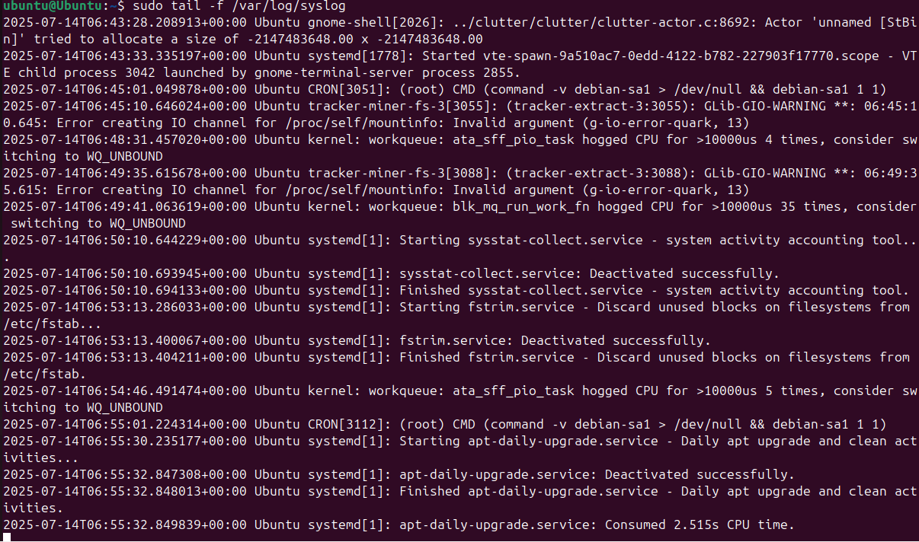

To moniter log file using grep command is
sudo tail-f /var/log/syslog | grep “system”
system =keyword to find in log file

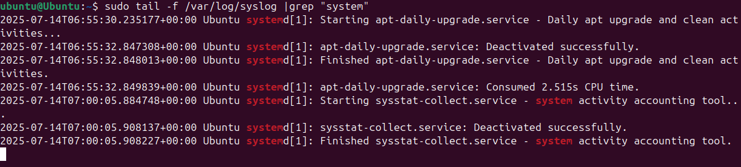

26)Set up a web server (e.g., Apache or Nginx).

To setup a webserver the command used is :
sudo apt install nginx

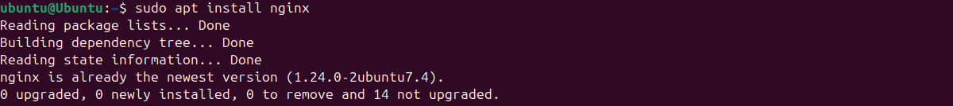

To start , stop nd check status of webserver the command is

sudo systemctl start nginx
sudo systemctl stop nginx
sudo systemctl status nginx
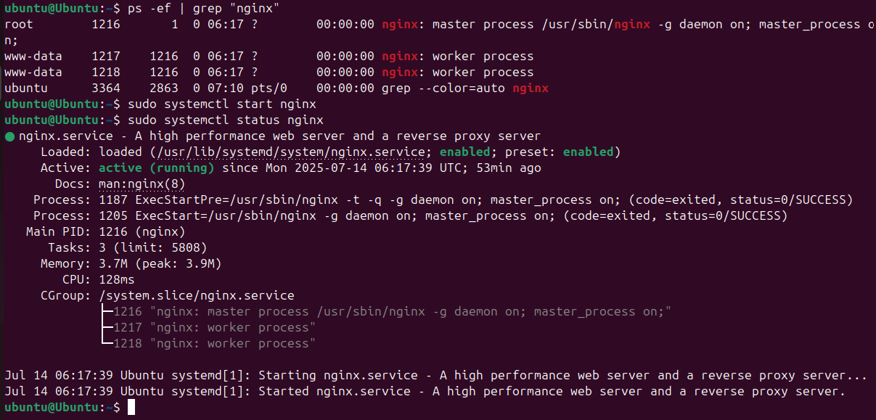

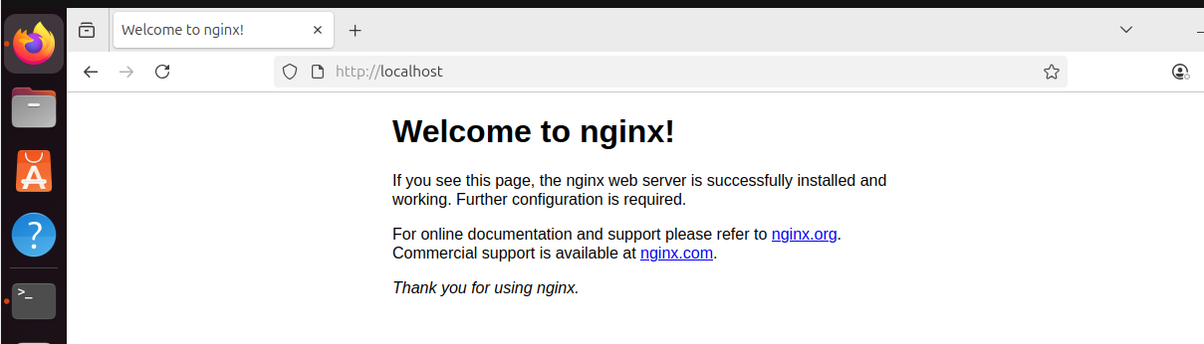

27)Configure and secure a MySQL Database.

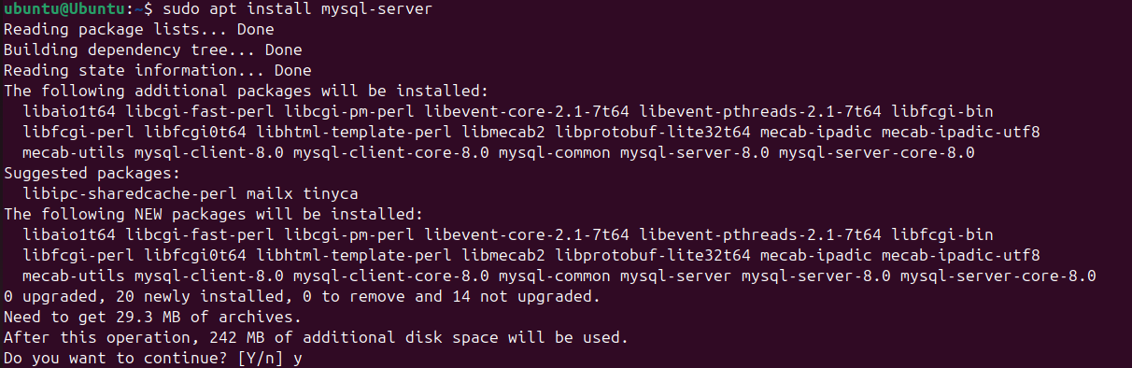

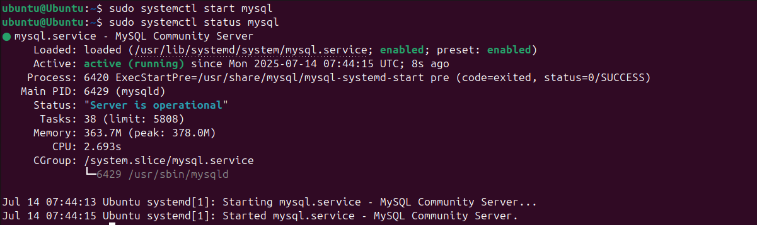
To secure mysql the command used is
sudo mysql_secure_installation

To login to mysql the command used below password is Mysql@123.
sudo mysql -u root -p

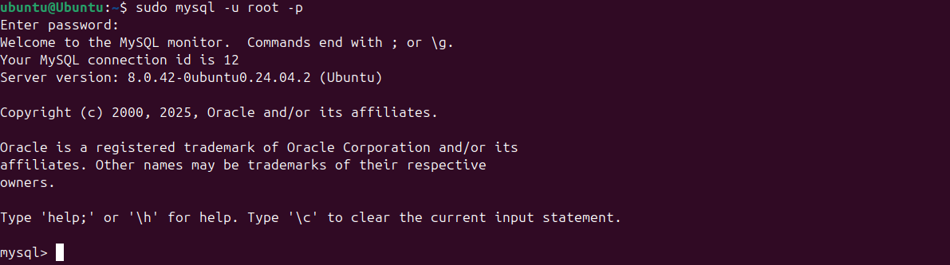

28)Set up a Application Server (e.g.,Apache Tomcat)

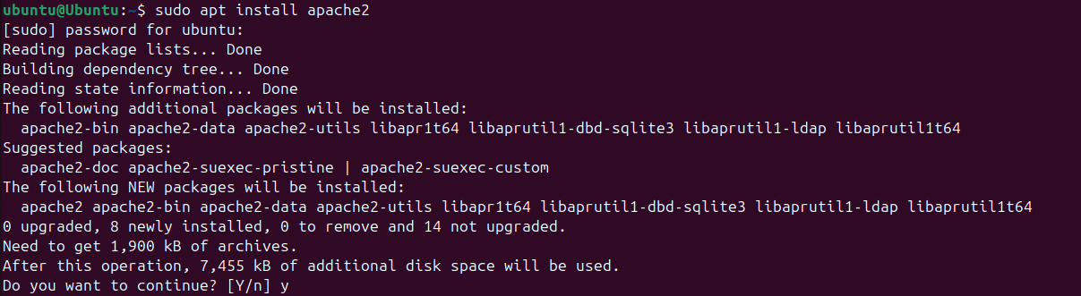

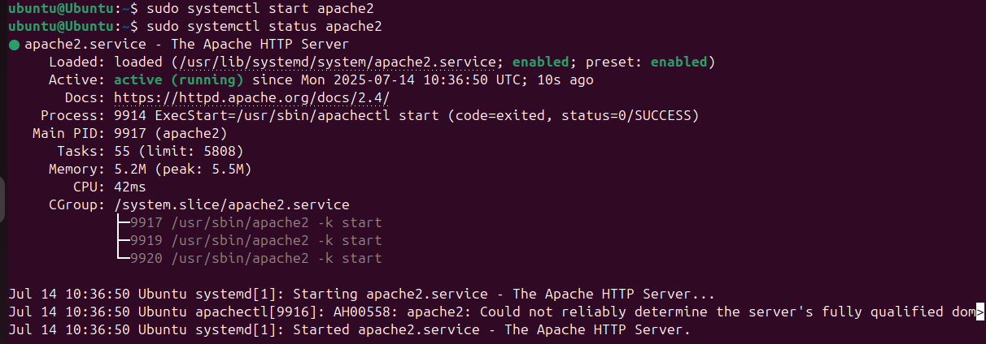

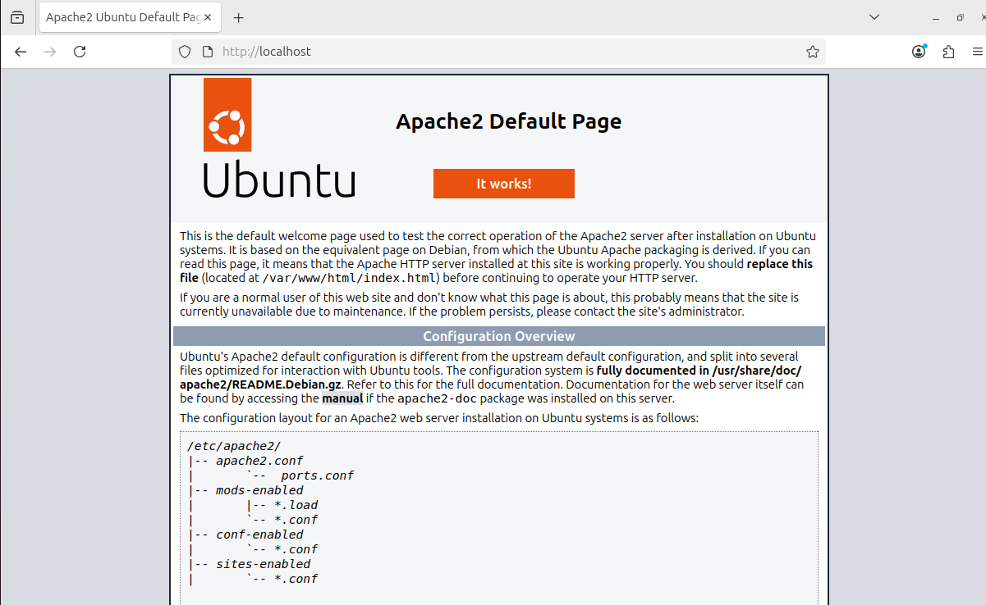

30)Print specific columns from a delimited file.

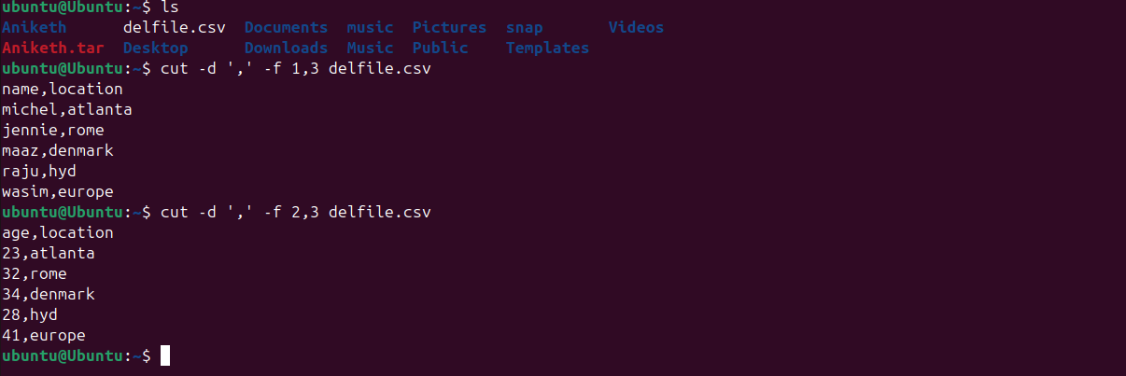

To print specific column frm delimited file the command is
cut -d ',' -f 1,3 filename.csv
-f 1, 3 are specific columns.

- Filter and print lines based on a specific pattern or condition.

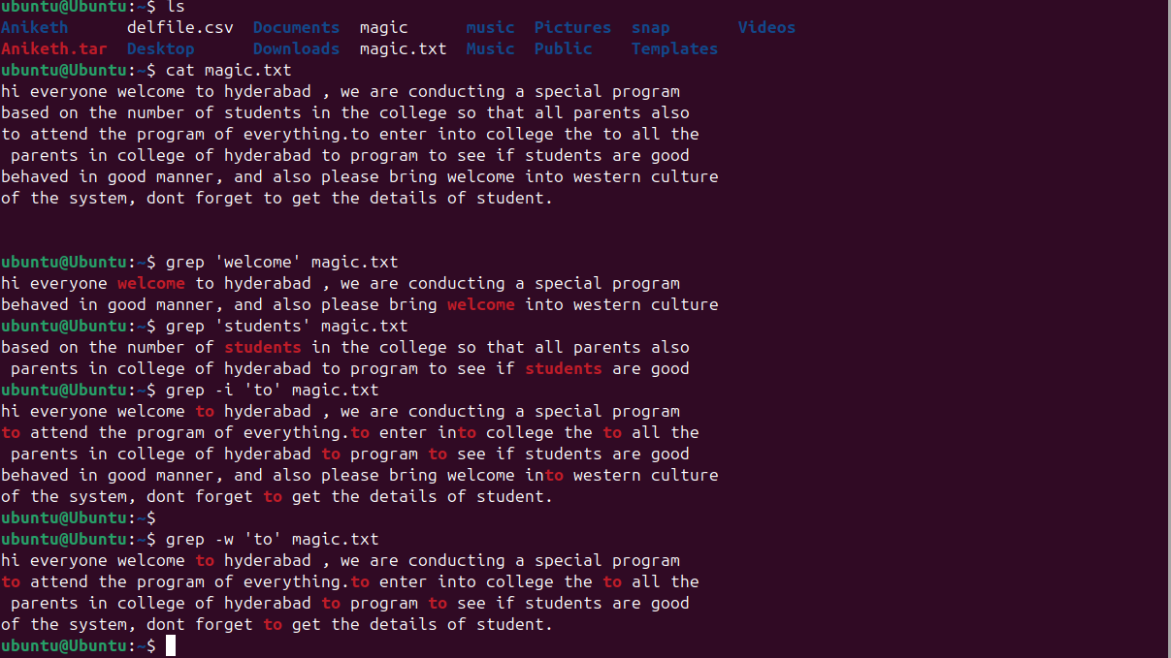

32)Calculate and print the average, sum, or other statistics of a column.
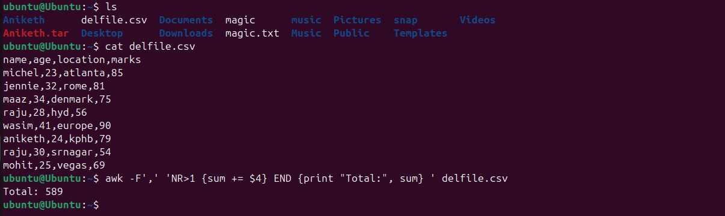

33)Perform string manipulation, such as extracting substrings or changing case.

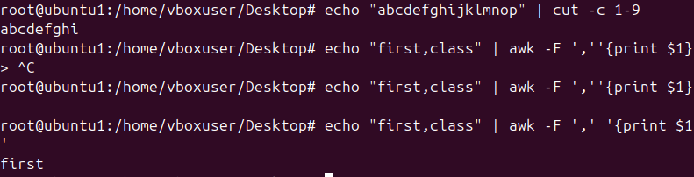

34)Count the occurrences of a specific pattern in a file.

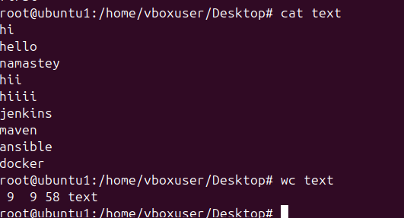

35)Sort lines based on a specific field or column.

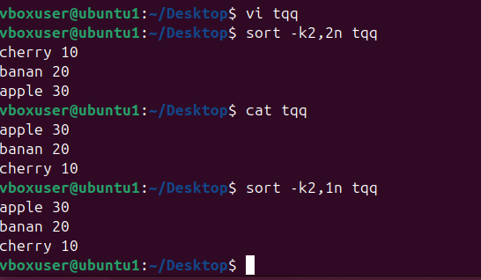

36)Merge multiple files based on a common field or column.

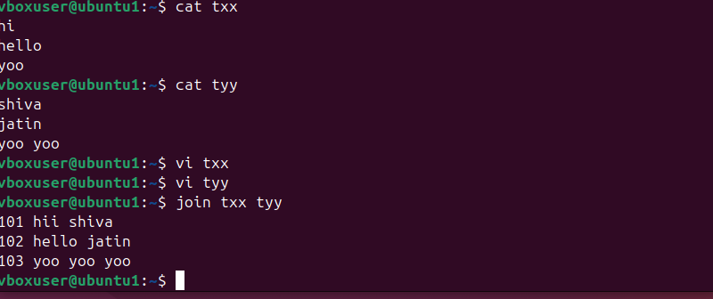

- Substitute text in a file using search and replace.

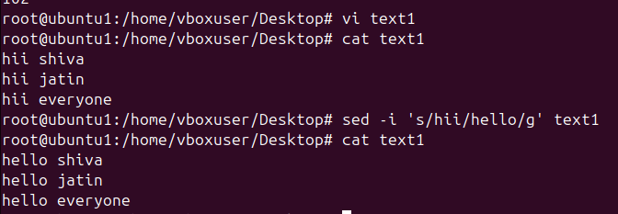

38)Delete specific lines based on a pattern or line number.

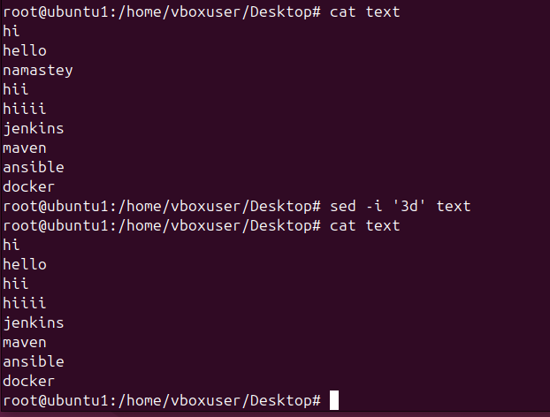

39)Append or insert text before or after a specific pattern
or line.

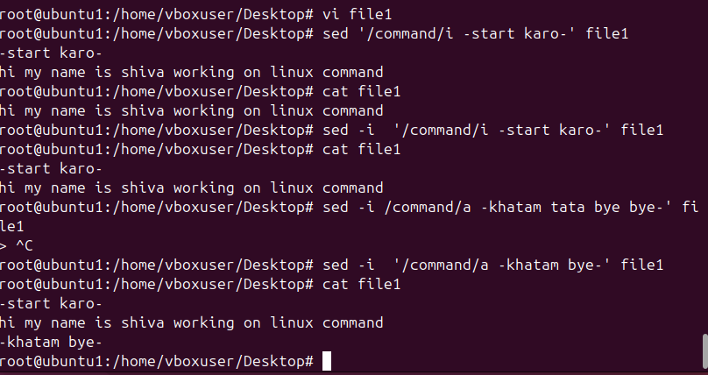

- Print only specific lines from a file.

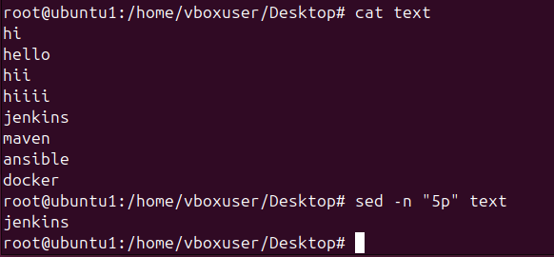

- Copy file from linux to windows machine
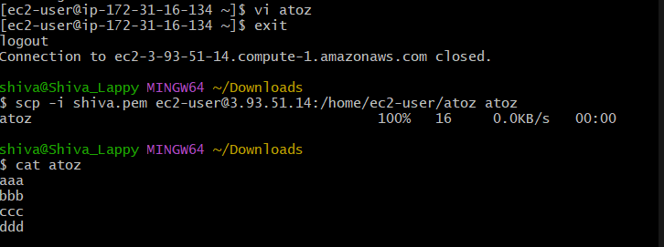

- 5 use cases for AWK and 5 use cases for sed

